**Exp 03 : Create a simple cloud software application for Property Buying and Rental System for Chennai city using Zoho Creator and demonstrate SaaS.**

**AIM:**

To create a cloud-based Property Buying and Rental System for Chennai city using Zoho Creator anD demonstrate SaaS.

**Procedure :**

1. Login to Zoho Creator and create a new app.

2. Design forms for Property Details, Buyer Information, Rental Requests.

3. Add workflows to filter properties by Chennai location.

4. Deploy the app on Zoho cloud.

5. Publish the application URL for users.

6. Test by searching and booking a property.

**Output :**

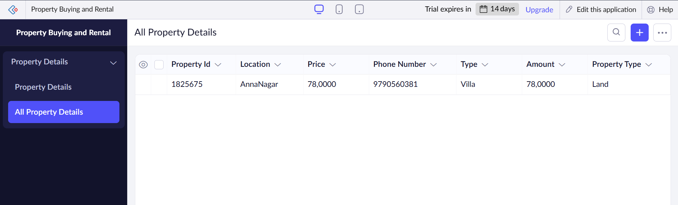

**Result :**

The Property Buying & Rental System was successfully deployed on Zoho Creator, accessible as a SaaS application.